**Week 4 Hands on practise solution**

**2. spring-rest-handson**

**Exercise 1:Hello World RESTful Web Service**

**Folder Structure:**

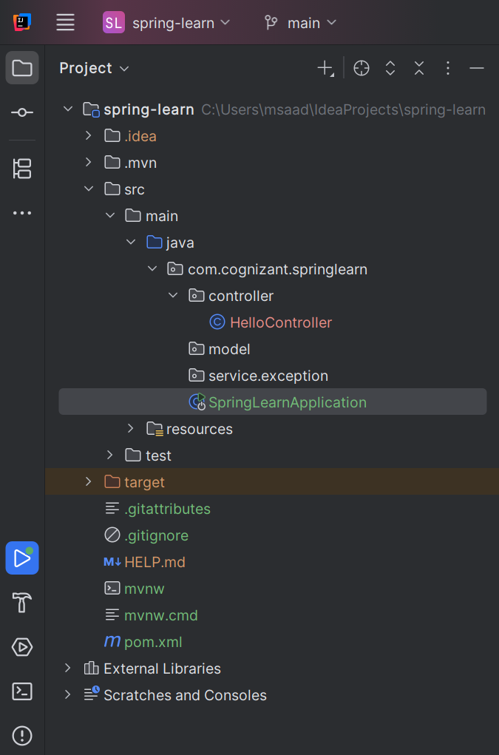

**HelloController.java**

package com.cognizant.springlearn.controller;  
  
import org.slf4j.Logger;  
import org.slf4j.LoggerFactory;  
import org.springframework.web.bind.annotation.GetMapping;  
import org.springframework.web.bind.annotation.RestController;  
  
@RestController  
public class HelloController {  
  
 private static final Logger *LOGGER* = LoggerFactory.*getLogger*(HelloController.class);  
  
 @GetMapping("/hello")  
 public String sayHello() {  
 *LOGGER*.info("START - sayHello()");  
 *LOGGER*.info("END - sayHello()");  
 return "Hello World!!";  
 }  
}

**SpringLearnApplication.java**

package com.cognizant.springlearn;  
  
import org.springframework.boot.SpringApplication;  
import org.springframework.boot.autoconfigure.SpringBootApplication;  
  
@SpringBootApplication  
public class SpringLearnApplication {  
  
 public static void main(String[] args) {  
 SpringApplication.*run*(SpringLearnApplication.class, args);  
 }  
  
}

**Run the SpringLearnApplication.java**

Then, open any browser and type**:** [**http://localhost:8080/hello**](http://localhost:8080/hello)

**Output:**

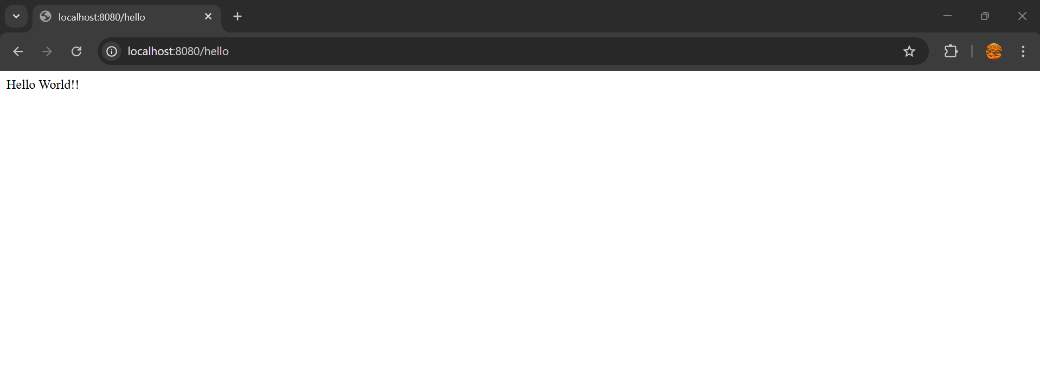

**Exercise 2: REST - Country Web Service**   
  
Write a REST service that returns India country details in the earlier created spring learn application.  
  
**URL**: /country  
**Controller**: com.cognizant.spring-learn.controller.CountryController  
**Method Annotation**: @RequestMapping  
**Method Name**: getCountryIndia()  
**Method Implementation**: Load India bean from spring xml configuration and return  
**Sample Request**: http://localhost:8083/country  
**Sample Response**:

{

  "code": "IN",

  "name": "India"

}

**Folder Structure:**

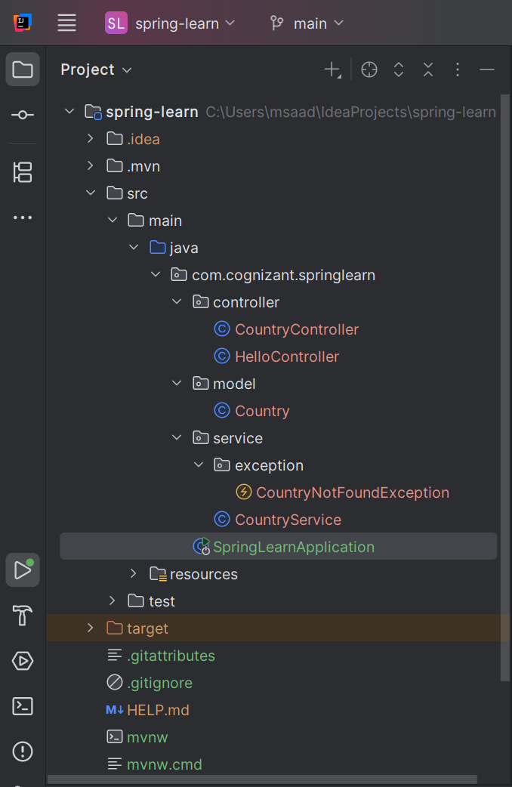

**Create 4 packages:**

**Controller, model, service, service.exception.**

**CountryController.java (in controller package)**

package com.cognizant.springlearn.controller;  
  
import com.cognizant.springlearn.model.Country;  
import com.cognizant.springlearn.service.CountryService;  
import com.cognizant.springlearn.service.exception.CountryNotFoundException;  
import org.springframework.beans.factory.annotation.Autowired;  
import org.springframework.web.bind.annotation.*;  
  
import java.util.List;  
  
@RestController  
public class CountryController {  
  
 @Autowired  
 private CountryService countryService;  
  
 // GET: /country → returns India  
 @GetMapping("/country")  
 public Country getCountryIndia() {  
 return new Country("IN", "India");  
 }  
  
 // GET: /countries → returns all countries  
 @GetMapping("/countries")  
 public List<Country> getAllCountries() {  
 return countryService.getAllCountries();  
 }  
  
 // GET: /countries/{code} → returns a country by code  
 @GetMapping("/countries/{code}")  
 public Country getCountry(@PathVariable String code) throws CountryNotFoundException {  
 return countryService.getCountry(code);  
 }  
}

**Country.java (in model package)**

package com.cognizant.springlearn.model;  
  
public class Country {  
 private String code;  
 private String name;  
  
 public Country() {}  
  
 public Country(String code, String name) {  
 this.code = code;  
 this.name = name;  
 }  
  
 public String getCode() {  
 return code;  
 }  
  
 public void setCode(String code) {  
 this.code = code;  
 }  
  
 public String getName() {  
 return name;  
 }  
  
 public void setName(String name) {  
 this.name = name;  
 }  
}

**CountryService.java (in service package)**

package com.cognizant.springlearn.service;  
  
import com.cognizant.springlearn.model.Country;  
import com.cognizant.springlearn.service.exception.CountryNotFoundException;  
import org.springframework.stereotype.Service;  
  
import java.util.Arrays;  
import java.util.List;  
  
@Service  
public class CountryService {  
  
 private static final List<Country> *countries* = Arrays.*asList*(  
 new Country("IN", "India"),  
 new Country("US", "United States"),  
 new Country("JP", "Japan"),  
 new Country("DE", "Germany")  
 );  
  
 public Country getCountry(String code) throws CountryNotFoundException {  
 return *countries*.stream()  
 .filter(c -> c.getCode().equalsIgnoreCase(code))  
 .findFirst()  
 .orElseThrow(() -> new CountryNotFoundException("Country not found"));  
 }  
  
 public List<Country> getAllCountries() {  
 return *countries*;  
 }  
}

**CountryNotFoundException.java (in service.exception package)**

package com.cognizant.springlearn.service.exception;  
  
import org.springframework.http.HttpStatus;  
import org.springframework.web.bind.annotation.ResponseStatus;  
  
@ResponseStatus(value = HttpStatus.*NOT_FOUND*, reason = "Country not found")  
public class CountryNotFoundException extends Exception {  
 public CountryNotFoundException(String message) {  
 super(message);  
 }  
}

**Now, run the SPringLearnApplication.java**

**Then, go to any browser and type,**

1. [**http://localhost:8080/countries**](http://localhost:8080/countries) **(to display all countries)**

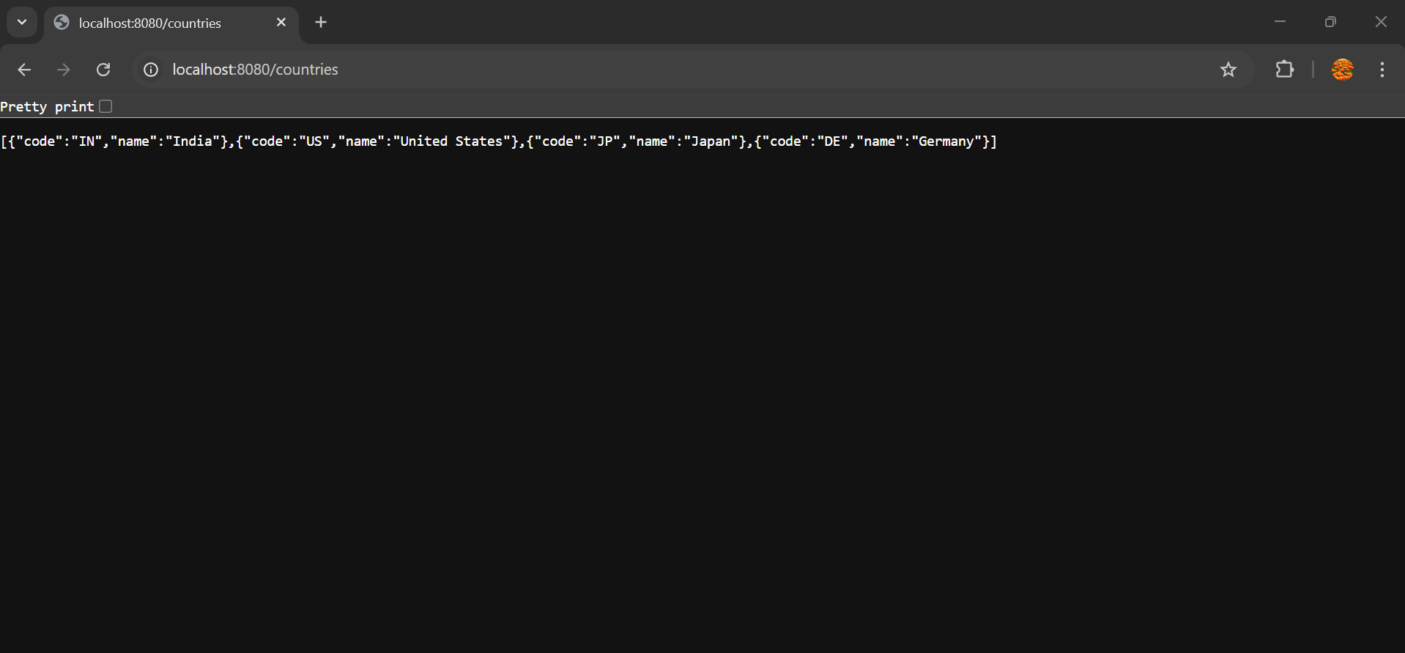

1. [**http://localhost:8080/countries/in**](http://localhost:8080/countries/in) **(to display specific country)**

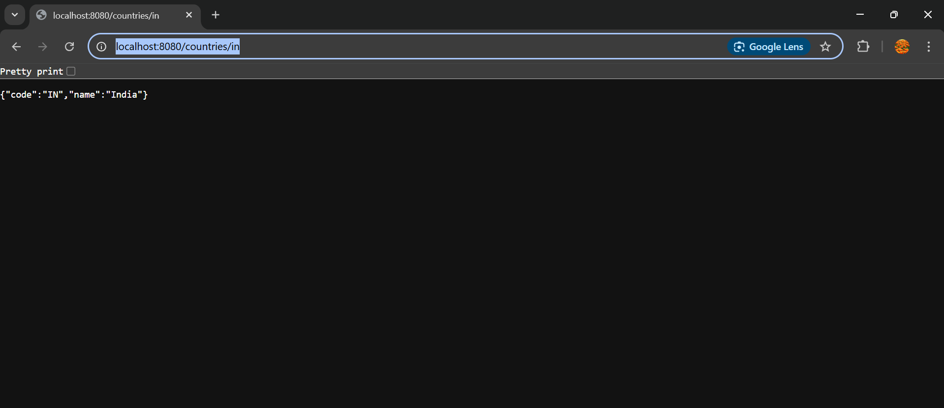

**Exercise 3:**

**REST - Get country based on country code**   
  
Write a REST service that returns a specific country based on country code. The country code should be case insensitive.  
  
**Controller**: com.cognizant.spring-learn.controller.CountryController  
**Method Annotation:** @GetMapping("/countries/{code}")  
**Method Name**: getCountry(String code)  
**Method Implemetation**: Invoke countryService.getCountry(code)   
**Service Method:**com.cognizant.spring-learn.service.CountryService.getCountry(String code)

**The folder structure and all the packages and classes remain the same which are used for the exercise above which is REST- Country Web Service**

**Output:**

<http://localhost:8080/countries/in>

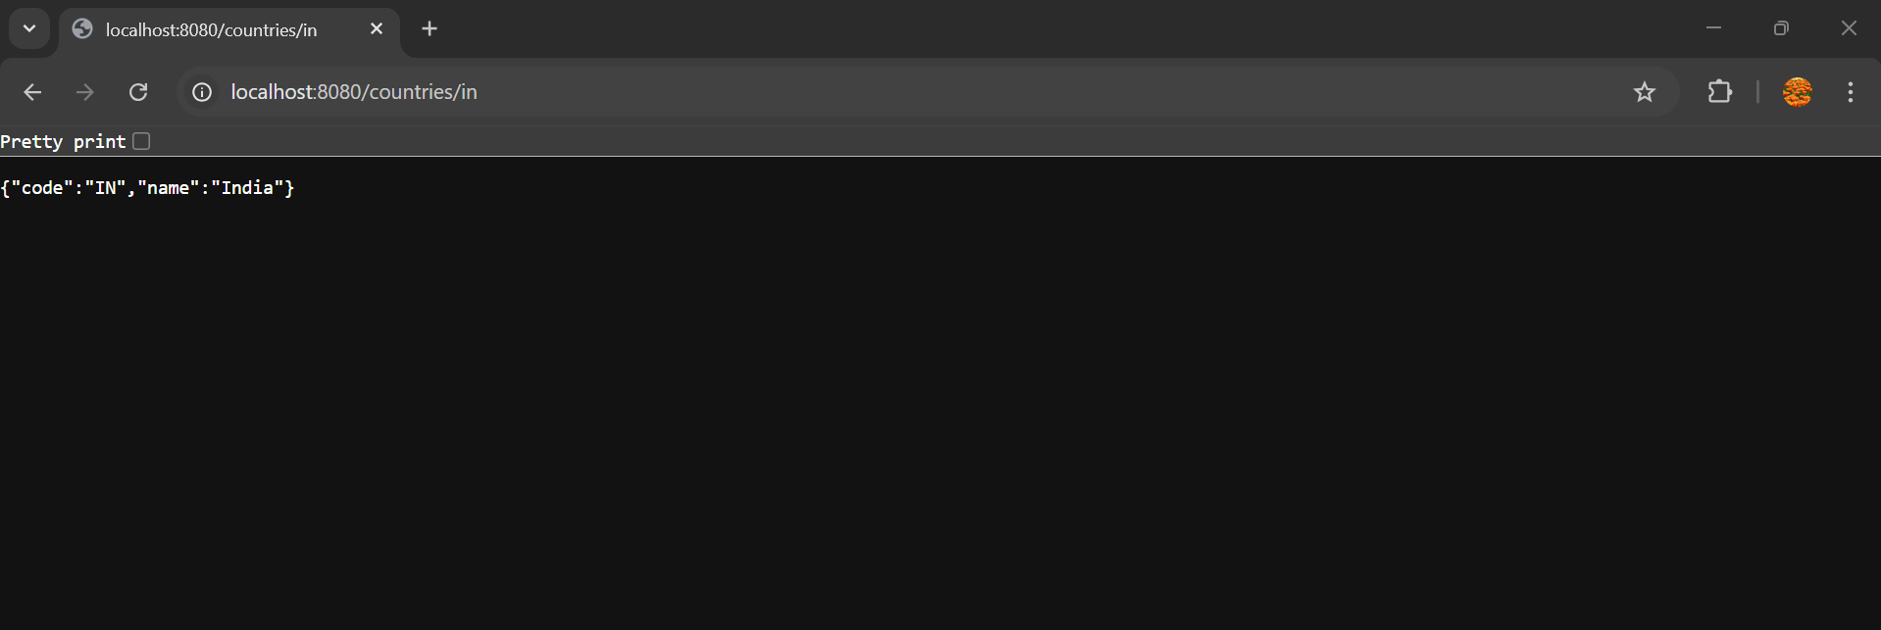

<http://localhost:8080/countries/us>

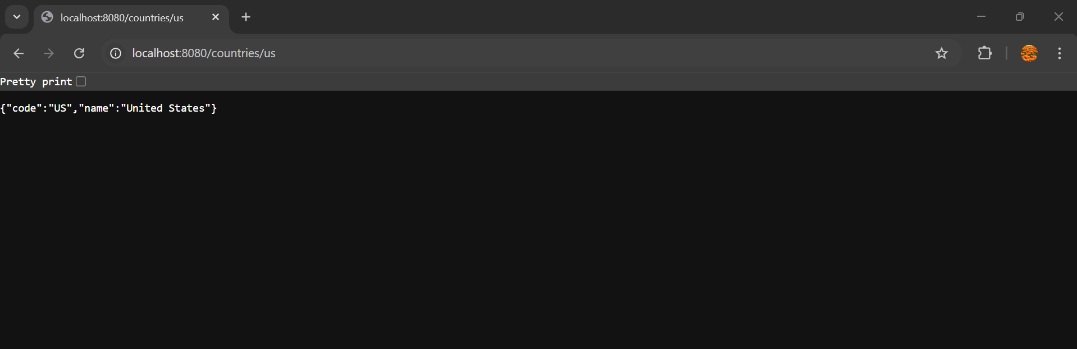

<http://localhost:8080/countries/jp>

